BATH & NORTH EAST SOMERSET COUNCIL - JOB DESCRIPTION

DIRECTORATE | Finance | POST NO: New Post
POST TITLE | Project Manager - iTrent HR & Payroll System Implementation | Grade 10
RESPONSIBLE TO: Financial Systems & Development Manager
REPORTING TO THIS POST: 1x Project Support Officer, 1x HR & Payroll System Lead
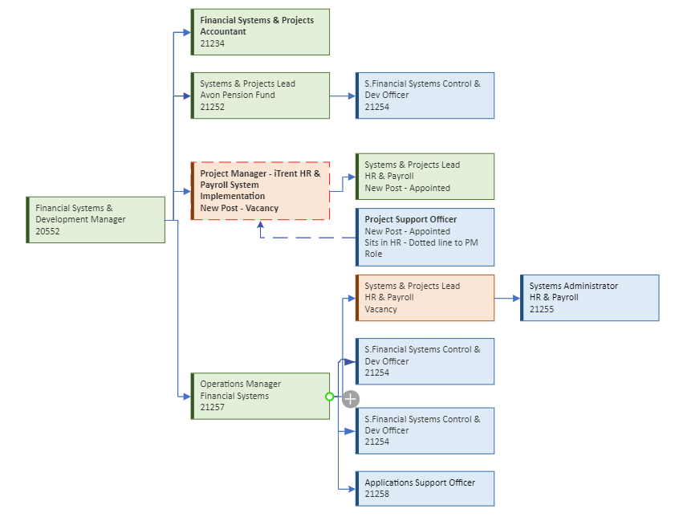

1. PURPOSE OF JOB

To project manage the implementation of the MHR iTrent HR & Payroll Application for Bath & North East Somerset Council, provide advice and guidance to project delivery colleagues, and diagnose potentially complex delivery issues, in order to support the effective management and delivery of this specific project within the Financial Systems and Development department.

2. PRINCIPAL ACCOUNTABILITIES

- Oversee the end-to-end implementation of the new iTrent system, supervising the outputs and performance provided by a multi-disciplinary team (including external consultants and third-party vendors) so that team members are able to produce quality project outputs, and support achievement of project objectives.

- Collaborate with internal stakeholders, external consultants, and third-party vendors to ensure a seamless transition.

- Oversee the data cleanse process to ensure accurate and reliable data migration.

- Coordinate the implementation of a new iTrent instance within the cloud, working directly with application vendor Midland HR.

- Facilitate communication and collaboration between Council employees and project teams.

- Monitor project progress, identify risks, and implement mitigation strategies.

- Use established systems to track key project metrics, benefits, budgets, risks and highlight variances and trends in order to manage and control project progress and contribute to its effective governance.

- Liaise with internal and external stakeholders/customers to help them understand project objectives and progress, manage expectations, and to deliver assigned part of programmes/projects and support effective collaboration. This may include supporting on external communications.

- Provide advice and subject matter expertise, so that projects within their area of the Council are delivered in accordance with standard techniques and best practice.

- Plan and carry out regular project quality reviews in order to identify, assess and take action to mitigate risks to project success.

- Manage, monitor and report on project funding and finances, to ensure that the projects are delivered within budget and that funding is spent in accordance with regulations and requirements.

- Lead project/workstream resourcing in ensuring that there are adequate resources to meet defined timescales and delivery. This includes highlighting periods of heavy activity and potential resourcing issues, and supporting in reallocating/reprioritising resources and project actions.

- Contribute to the identification and implementation of continuous improvements in their area of the Council, to support the quality/performance of project management and delivery of fit for purpose initiatives. This will include analysis of trends and interpreting and evaluating best courses of action.

3.VALUES AND BEHAVIOURS FRAMEWORK: Improving People’s Lives

 |  | We are bold in our approach, set aspirational goals for ourselves and create innovative solutions to tackle problems and adapt to changing circumstances. This value demonstrates that we are proactive, take action and deliver outcomes which improve people's lives.
 |  | We empower our staff and the people of Bath and North East Somerset so that they have the confidence and ability to find solutions for themselves and others. This value demonstrates how we develop our staff so that they are knowledgeable, are trusted to make decisions, able to challenge us and have the authority to be enablers.
 |  | We are supportive and work together to build trusting relationships. Our staff give help and encouragement to the people of Bath and North East Somerset and each other. This value describes how we are curious, collaborative and care for each other, our residents and the environment.
 |  | We are transparent, honest and accountable. This value demonstrates that we act with integrity, are open to criticism, are honest about our mistakes and want to improve and do better so that we deliver on our promises.
These Values are underpinned by a set of behaviours for all staff, managers, and leaders. These Values and Behaviours are used to support and inform our recruitment decisions, staff development and organisational behaviour.
4. DIMENSIONS
This role will manage, supervise, and guide more junior project staff and the project delivery team, checking performance and standards.
This role does not manage any direct budgets but will support the management and control of budgets through monitoring and challenge against spend.
Planning will typically be over days and weeks, and the role holder will need to work with stakeholders, and be able to organise their own time, and plan projects.

Other Dimensions:
Number of Payroll system users 500
Value of Payrolls per annum £130m
5. PHYSICAL EFFORT AND WORKING ENVIRONMENT

The council operates a Flexible Hybrid working environment which means the ability to work from home and the office, you will be required to attend the office when business needs dictate this is essential.
Where electronic communication options are not available or suitable, some travel may be required to attend client meetings, training, and public sector conferences.

6. GENERAL

The post holder will be expected to undertake such other duties and responsibilities as are specified by the Financial Systems & Development Manager and are commensurate with the level of the post and may on occasion be required to work outside of normal office hours to meet specific requirements.

This job description is not a complete list of duties but gives a general indication of the range of work undertaken. It will vary over time as demands and priorities change. The team structures within the Service operate with a high degree of collaboration and flexibility, individual service portfolios may therefore change over time and post holders are expected to undertake any other duties commensurate with the general level of responsibility of the post.

6. PERSON SPECIFICATION
POST TITLE | Project Manager
QUALIFICATIONS: |  | Essential | Desirable
Degree or equivalent specialist experience in the project management discipline. |  | √
Relevant project management qualification, e.g. PRINCE2, or equivalent knowledge and experience of project management methodologies, concepts, and principles. |  | √
Working towards professional membership or accreditation in a specialist field relevant to the discipline e.g CIPP Chartered Institute for payroll and pension, ITIL or Similar |  |  | √
Knowledge & Experience:
Proven experience as a Project Manager with experience delivering an IT application implementation |  | √
Familiarity with HR & Payroll systems, preferably iTrent. |  |  | √
Strong communication and leadership skills. |  | √
Able to create innovative solutions to complex problems, consistently exhibiting decisiveness, adaptability and the ability to work without supervision, to a high standard and within tight timescales and deadlines. |  | √
Ability to analyse and present information including statistical data and prepare reports |  | √
Proven experience in the ability to plan, organise, prioritise, and manage people and resources |  | √
Experience of working with stakeholders, keeping them informed on projects, and providing advice and guidance. |  | √
Ability to communicate clearly and persuasively with a range of stakeholders. |  | √
Ability to direct project teams and supervise the quality of outputs. |  | √
Possess high level of awareness in the role of systems in delivering service improvement |  | √
Possess a high level of awareness and understanding of the role of IT in supporting systems |  | √
Knowledge of HR & Payroll including a general, broader understanding of the public sector and the issues that it faces (including knowledge of local government structures and partnerships). |  |  | √

