BATH & NORTH EAST SOMERSET COUNCIL - JOB DESCRIPTION

DIRECTORATE |  | Bath Heritage Services | POST NO: 32449
POST TITLE |  | Digital Marketing Officer | GRADE: 5
RESPONSIBLE TO: Communications and Content Manager
REPORTING TO THIS POST: NA
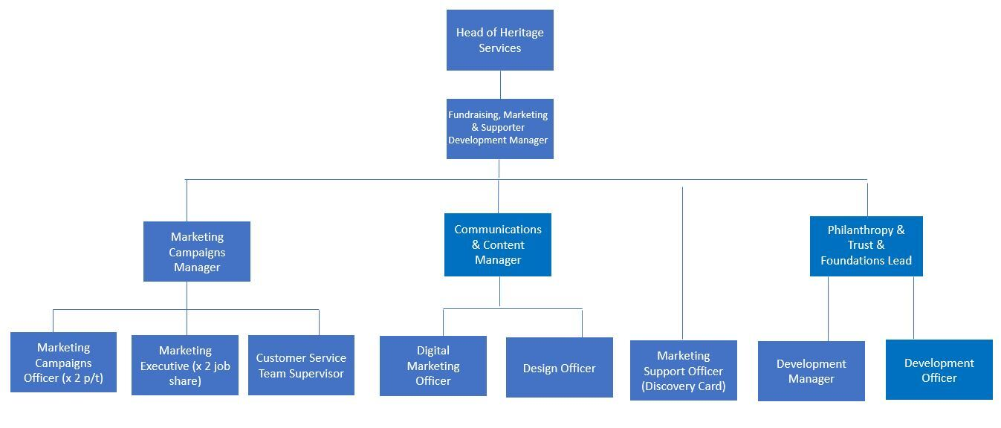

1. PURPOSE OF JOB
The primary purpose of the role is to oversee Heritage Services’ digital space using website, e-newsletters, and social media to engage online audiences.
The Digital Marketing Officer will work with colleagues across the service to bring out the best stories and present them effectively across the different channels to ensure community engagement and commercial sales for the Roman Baths, Fashion Museum, Victoria Art Gallery, Bath’s Historic Venues and Bath Record Office.
The role will support the Communications and Content Manager to build our digital marketing strategies and create compelling content to support the overall marketing strategy and related targets.

2. PRINCIPAL ACCOUNTABILITIES

Service Delivery

Website Maintenance:
- To update the Heritage Services Suite of websites; to ensure that content is current and optimised; to work with other departments within the service to ensure that website information is accurate and up to date.
- Together with the Communications and Content Manager to work with the wider Heritage Services team to create engaging content for websites; this will include checking copy and updating content / helping them to update content where necessary.
- To liaise with the web developers on web platform developments to accommodate and test new functionality and security updates.
- To regularly review the websites using Google Analytics and other tools to ensure that they reflect user journeys and the needs of our visitors and web users.

Social Media Monitoring and Content Creation:
- The day to day running of all social media channels – including maintaining the marketing team content calendar and devising engaging content for social media channels to drive visitors, brand awareness and engagement.

- To monitor and reply to queries and posts that come in via the Service’s social media accounts. To engage with visitors via the Service’s social media platforms including Facebook, X, Instagram, Pinterest, TikTok, YouTube etc.
- To support PPC campaign strategies and activities, working with the appointed PPC agency.
Email Marketing and Newsletters
- To produce email newsletters for the Service’s museums, Discovery Card holders (and others as required) and distribute these to agreed mailing lists, updating and managing these lists as necessary.
- Working with the wider marketing team to create engaging email marketing campaigns that will drive engagement with our audiences.
Reporting and Analysis
- To monitor and analyse digital channels and campaigns against key performance metrics and together with the Content and Communications Manager identify areas for improvement.

- To deliver regular reports on digital channel performance against KPIs, as directed by Content and Communications Manager and Marketing Campaign Manager.

- To monitor review sites such as Trip Advisor and Google reviews, and to respond to reviews and queries in a timely manner.

- To assist in the collection of visitor data and customer feedback through issuing visitor surveys and using this data in appropriate promotional material and to inform service developments.

Management

- Work collaboratively with other departments across the organisation to create content for digital channels, that is both accurate and consistent with museum brand.
- To assist with ensuring effective external and internal working relationships are established and maintained with organisations and agencies relevant to the work of the team, in particular the appointed website design and PPC provider.

- Together with the Campaigns Manager to liaise with department’s marketing agency in China about any digital promotional activity that we have in place in China for the Roman Baths and Fashion Museum. To work with the agency to agree a monthly content schedule and create content that will engage with the Chinese Market.

Working in a team
- To work with the wider marketing team on creative and compelling ways to market the Heritage sites – including proposals on how to incorporate the latest social media trends and developments.

- With the Communications and Content Manager and wider marketing team, to participate in the formulation and implementation of detailed team objectives and policies.

- To assist marketing team with filming and photography requests and to supervise film/photography crews on site when needed.

- To work with the Content and Communications Manager in digital project administration using standard project management tools, keeping up to date project timetables and an action list.
Service Development and/or Delivery

- To take part in relevant team meetings and write and circulate action lists of agreed actions. To plan these meetings, including setting up AV and internet access where relevant.

- To manage the digital and printed photographic libraries for marketing purposes, replenishing photo stocks as necessary. To make images accessible to internal and external enquirers.

- To assist in the management of content and photographs and copy-writing and editing where required.

Other

- Adopt a proactive approach to developing and maintaining excellent relationships and communication channels with a wide range of contacts including managers, external clients and suppliers, staff and employee representatives.

- Ensure conformance to equal opportunity and data protection policies.

- There will be occasions when additional hours working is required and this may include weekends or evenings.

- The post is designated as politically restricted under the 1989 Local Government and Housing Act.

3.VALUES AND BEHAVIOURS FRAMEWORK: Improving People’s Lives
 |  | We are bold in our approach, set aspirational goals for ourselves and create innovative solutions to tackle problems and adapt to changing circumstances. This value demonstrates that we are proactive, take action and deliver outcomes which improve people's lives.
 |  | We empower our staff and the people of Bath and North East Somerset so that they have the confidence and ability to find solutions for themselves and others. This value demonstrates how we develop our staff so that they are knowledgeable, are trusted to make decisions, able to challenge us and have the authority to be enablers.
 |  | We are supportive and work together to build trusting relationships. Our staff give help and encouragement to the people of Bath and North East Somerset and each other. This value describes how we are curious, collaborative and care for each other, our residents and the environment.
 |  | We are transparent, honest and accountable. This value demonstrates that we act with integrity, are open to criticism, are honest about our mistakes and want to improve and do better so that we deliver on our promises.
These Values are underpinned by a set of behaviours for all staff, managers, and leaders. These Values and Behaviours are used to support and inform our recruitment decisions, staff development and organisational behaviour.
4. DIMENSIONS

The Digital Marketing Officer will work alongside the Marketing Team within a designated service portfolio with a high degree of diversity with variable workforce compositions, business needs and priorities as outlined below.

The business.

Heritage Services is a business unit within the Council with bespoke financial and governance arrangements agreed by the Council in 2004. It works to rolling 5-year financial targets agreed by Cabinet annually and supported by business planning, review and monitoring processes that have been cited as ‘national best practice’ by the Audit Commission, and ‘local excellent practice’ by the Council’s internal auditors. The Philanthropy & Trust & Foundations Lead plays an important and central role in supporting the delivery of the business plan to achieve the Council’s financial targets.

Business performance.

Heritage Services competes commercially in the national and international Visitor Attractions sector. The Service welcomes c.1 million visitors every year, most of them visiting Bath and its attractions for the first time. The Roman Baths & Pump Room is the only local authority-run visitor attraction in the UK to be a member of the Association of Leading Visitor Attractions (ALVA) and is the only local authority service of its kind to operate at no cost to the local taxpayer. The Service delivers an annual profit, after all costs, of c.£6 million p.a. and competes in the national and international visitor and tourism market. The annual profit generated is equivalent to a reduction of £71 in every Council Tax bill within the district.

Heritage Services budget (2023/24):
- external turnover £21 Million p.a.
- net profit to the authority of £10.6 Million p.a.

Marketing Budget
The Marketing team has an approximate expenditure budget of £750,000 and the postholder will be responsible for monitoring the PPC advertising budget, supported by the Marketing Campaign Manager and Content and Communications Manager.

Economic impact (2017/18):
- the Roman Baths levers £107m p.a. into the local economy (University of Bath 2012);
- Heritage Services’ net profit to the authority of £10.6m p.a. equates to:
- £56 net income per resident of B&NES (approx.);
- £65,000 net income per Heritage Services staff member.

Supporter Development
The Service is looking to move away from a transactional approach to its engagement with users. We’d like to change the way that we see the people who interact with us from visitors, funders, customers, Discovery Card Holders etc to ‘Supporters’. Our overriding aim will be to connect people emotionally with our mission and provide different ways for them to make an impact alongside us. This will mean a review of our digital infrastructure, our audience understanding and our culture.

Fundraising
The Service is adept at raising funds from Grants, Trust and Foundations. However, a lack of capacity previously has meant that Corporate partners and individual donors are not currently engaged as well as would be expected. The Fundraising, Marketing and Supporter Development Manager role was introduced in April 2023 to bring a strategic overview to marketing and fundraising endeavors across the organization. They are now developing a strategy and building a team to ensure fundraising success for the organization.

Service Scope:
Heritage Services includes a number of service areas whose activities are eligible for grant-aid from external sources. These include:
- The Roman Baths and Pump Room
- Victoria Art Gallery
– Bath Record Office

The Service works closely with the World Heritage Manager and has an ongoing interest in the presentation and interpretation of the ‘City of Bath’ UNESCO World Heritage Site.

There are three independent charities which support our work: The Roman Baths Foundation, the Fashion Museum Foundation and the Friends of Victoria Art Gallery.

5. PHYSICAL EFFORT AND WORKING ENVIRONMENT

Physical Effort.

The post may require occasional physical effort in transporting portable exhibition stands and other promotional materials. Reasonable workplace adjustments can be made if the post holder indicates that he/she has a condition that makes him/her unable to do this.

On occasion, it is necessary to carry materials or equipment from the ground floor. Manual Handling training is provided.

Working Environment.

The post is normally office-based but some outdoor work may be required, such as in the Roman Baths. The post-holder is required to walk between the Pump Room and Victoria Art Gallery on a regular basis (1km). The office is on the third floor of the Pump Room office block and there is no lift; reasonable workplace adjustments can be made if the post holder indicates that he/she has a condition that makes him/her unable to work in this office.

Health & Safety at Work

Employees at all levels (which for the purposes of this policy includes Councillors, volunteers and contractors working for the Council) are charged under the Health and Safety at Work, etc. Act 1974 with the duty of care for their own safety, the safety of fellow-workers, and of any other person affected by the Council's work activities. Employees also have a duty to co-operate with the Council to enable it to carry out its responsibilities and not to interfere with anything organised to promote health, safety and wellbeing. Thus, the Council looks to every employee to maintain continuous awareness of safety requirements, alertness to existing or potential hazards and awareness of the importance of working safely, minimising risk and reporting hazards.

Equalities

Bath and North East Somerset Council is committed to equality of opportunity for everyone and believes that the diversity of the local community is a major strength that contributes to the social and economic prosperity of the area.

The Council will ensure that no resident of, or visitor to the area, job applicant, employee or other person associated with the Council is treated inequitably or in an unlawful or unjustifiably discriminatory manner.

Employees have a duty to undertake their roles and ensure that they and others adhere to the Council’s equalities policy and procedures.

6. GENERAL

Undertake such other duties and responsibilities as are specified by the Head of Service and are commensurate with the level of the post. This job description is not a complete list of duties but gives a general indication of the range of work undertaken. It will vary over time as demands and priorities change. The team structures within Heritage operate with a high degree of collaboration and flexibility, individual service portfolios may therefore change over time and post holders are expected to undertake any other duties commensurate with the general level of responsibility of the post.

6. PERSON SPECIFICATION
POST TITLE
QUALIFICATIONS: |  | Essential | Desirable
Educated to degree level of equivalent |  | X
PERSONAL QUALITIES
Highly organized with ability to prioritize a busy workload and meet multiple deadlines. |  | X
A passion for digital marketing and social media; knowledge of current trends in social media and digital marketing, including emerging technologies and changes in digital platforms. |  | X
Excellent written and communication skills, as well as analytical organisational and interpersonal skills |  | X
A proactive ‘can do’ attitude with and eagerness to learn and try new ideas. |  | X
KNOWLEDGE & EXPERIENCE
At least 2 years’ experience working in a busy marketing, communications and/or digital department at a museum, heritage site, visitor attraction or charity. |  | X
Experience in creating, maintaining and updating websites and working with a variety of stakeholders to ensure content is regularly updated, correct and engaging for visitors. |  | X
SEO knowledge and copywriting skills |  | X
Experience in managing multiple social media channels and creating multi-media content to best engage with audiences according to channel. |  | X
Experience in creating newsletters and email marketing campaigns using e-marketing programmes such as MailChimp or similar. |  | X
Experience in analysing and creating informative reports on digital marketing channels and campaigns; providing insight and recommendations for improvement. |  | X
Knowledge of a range of social media and reporting tools including Google Analytics, Hootsuite, Canva, Facebook, X, Instagram, TikTok, Pinterest, YouTube.  Knowledge of website CMS (Drupal would be an advantage) |  | X
Experience in creation of creating and using a variety of media across digital channels including video, live-streams, photography, reels etc. |  | X

