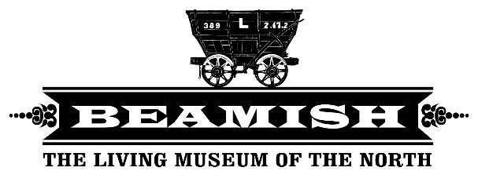

**Job Description**

**Job title:** People Development Assistant (Maternity Cover)

**Responsible to:** People Manager and Director of People and Culture

**Purpose:** To support the learning and development requirements of Beamish’s staff, volunteers and apprentices. Ensuring that their needs are placed at the centre of organisational growth and development, enabling people to gain the skills and knowledge they will need to deliver the museums operational plans and strategy.

**What you will do/key outcomes**

**Training and Development**

* Support the identification of training needs and maintain a training matrix for roles across the museum
* Plan and book training for staff and volunteers
* Coordinate and organise the annual “Connect days.
* Assist with administration of all talent development programmes within the museum
* Keep accurate records of training attendance and achievement of certificates up to date
* Work with line managers to ensure compulsory training is undertaken within the required timescales.
* Collate team training plans.
* Manage the online training platform (iHASCO) and maintain accurate records.
* Coordinate and organise the delivery of induction for all new staff
* Research learning and development practices and opportunities to meet the needs of individuals, teams and the museum.
* Consider equality, diversity and inclusion across all training and development within the museum.

**Supporting the development of Apprentices, Staff and Volunteers.**

* Assist with ensuring apprentices are supported in their work at Beamish.
* Support the development of learning opportunities for colleagues and volunteers across Beamish
* Work with local colleges and training providers to open up opportunities for training and potential apprenticeships.

**Reporting and Evaluation**

* Provide regular training related reports and analysis
* Ensure development opportunities are approached and communicated fairly in line with the museum training policy.

**Financial responsibilities**

* Ensure good value for money for training courses and development opportunities by procuring all services and supplies according to the Museum’s financial procedures

**General responsibilities**

* Support the HR and People Development team with recruitment activity as required.
* Adherence to confidentiality and museum values
* Attend meetings such as Team Leader meetings, Operational Management Meetings and Monthly Staff & Volunteer Catch Ups.
* To carry out the duties of the post in accordance with the Museum’s policies and procedures.

The People Development Assistant will from time to time be expected to carry out a range of other duties commensurate with the grade and falling within the scope of the post, as requested by management.

**About You**

You will:

* Be highly organised, able to prioritise competing demands and manage workloads effectively
* Comfortable in the use of databases and using excel to produce reports
* Analytical
* Build positive relationships internally and externally, building collaboration and trust
* Be confident and adaptable, able to tackle tasks with enthusiasm
* Strong written skills to produce reports
* Work as part of a team whilst being self-motivated to take initiative