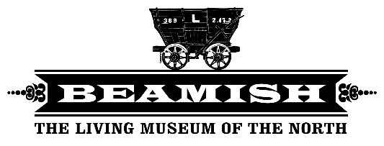

**Job title:** 1950s Town Engager  
 (Seasonal 0 – 37 hours)

**Responsible to:** 1950s Town Team Leader

**Job Location:** 1950s Town

**Team:** 1950s

**Key internal relationships:** 1950s Team Leader, 1950s Supervisor, Engagers, Volunteers.

**Purpose of the role:**

Working as part of the 1950s Town Team, you will deliver high quality engagement to our visitors. You will communicate the social history and heritage of the North East in the 1950s to create dynamic, memorable and emotionally engaging experiences for our visitors.

**About you**

**You will**

* Have outstanding communication skills and the ability to engage enthusiastically and effectively with a diverse range of people, tailoring your delivery of information to meet a variety of needs
* Have a hands on approach and be able to encourage visitors to get involved in on site activities
* Work well in a team, helping to deliver activities and events when required
* Work with attention to detail and a commitment to high standards
* Have an interest in the social history of the North East of England
* Have experience (or an understanding) of good customer service
* Have experience of working with members of the public on a daily basis
* Have an enthusiastic ‘can do’ approach and a wiliness to work in different exhibits, carrying out different tasks and activities
* Have a flexible approach to work hours and an ability to work weekends, bank holidays and evenings as required
* Be able to undertake a variety of manual handling duties appropriate to the post
* Have experience of using a till and handling cash with a focus on customer service
* Experience in hairdressing would be an advantage

**What you will do**.

* Work with colleagues, with an absolute focus on the visitor, to help deliver a world class experience within the living museum.
* Assist in the delivery of engagement across the 1950s town across a variety of exhibits
* Engage visitors to the museum using a variety of different techniques
* Communicate the social history of the North East of England in 1950s accurately and effectively to our visitors
* Help to ensure safe and good management and housekeeping of all areas of work
* Assist colleagues in maintaining attention to detail in all museum activities
* Engage with children of all ages and deliver learning activities when required
* Work collaboratively to support other staff, volunteers and placements when required
* Work flexibly to support the delivery of museum events, including working late evenings, weekends and school holidays
* Adhere to operating procedures and risk assessments to facilitate safe, smooth and timely delivery of services
* Ensure health and hygiene standards are adhered to in all food preparation

**General responsibilities**

* Carry out duties of the post in accordance with the Museum’s Policies and procedures.
* Undertake such duties as are required from time to time as commensurate with the grade of the post

**All new appointments are subject to the receipt of satisfactory references, medical report, criminal conviction vetting clearance and proof of eligibility to work in the UK.**

**We recruit on the basis of aptitude positive attitude and potential, and work to ensure people from all backgrounds have the opportunity to work within the heritage sector. This is prioritised above academic qualifications and we support non-traditional routes into work. We recognise and value transferable skills and diverse experiences as a form of expertise. We particularly welcome applications from disabled and Black, Asian and Minority Ethnic candidates as well as applications from, LGB, Trans and non-binary candidates as underrepresented people within the museum.**

**Note to applicants: Please try to show in your application how you specifically meet the requirements in the about you section.**