

Legislative Researcher/Paralegal

Job pack

Thanks for your interest in working at Citizens Advice. This job pack should give you everything you need to know to apply for this role and what it means to work at Citizens Advice.

In this pack you’ll find:
- Our values
- 3 things you should know about us
- Information about the team, organisation and role
- The role profile and person specification
- Terms and conditions
- The benefits of working at Citizens Advice
- Our approach to equality and diversity
Want to chat about this role?
If you want to chat about the role further, you can contact ​the recruiting manager, Katie King, by emailing katie.king@citizensadvice.org.uk.

 Our values
We’re inventive. We’re not afraid of trying new things and learn by getting things wrong. We question every idea to make it better and we change when things aren’t working.
We’re generous. We work together, sharing knowledge and experience to solve problems. We tell it like it is and respect everyone.
We’re responsible. We do what we say we’ll do and keep our promises. We remember that we work for a charity and use our resources effectively.
 | 3 things you should know about us

1. We’re local and we’re national. We have 6 national offices and offer direct support to people in over 290 independent local Citizens Advice services across England and Wales.

2. We’re here for everyone. Our advice helps people solve problems and our advocacy helps fix problems in society. Whatever the problem, we won’t turn people away.

3. We’re listened to - and we make a difference. Our trusted brand and the quality of our research mean we make a real impact on behalf of the people who rely on us.

 How our organisation works

The Citizens Advice service is made up of Citizens Advice - the national charity - and a network of around 300 local Citizens Advice members.  This role sits in the national charity, which includes:  - 800 national staff working in one of our 6 offices or as homeworkers, or as part of the Witness Service from over 240 courts across England and Wales  - 3,000 Witness Service volunteers  Our network members are all independent charities, delivering services from:  - over 600 local Citizens Advice outlets  - over 1,800 community centres, GPs’ surgeries and prisons  They do this with:  - 6,500 local staff  - over 23,000 trained volunteers  Our reach means 99% of people in England and Wales can access a local Citizens Advice within a 30-minute drive of where they live. | 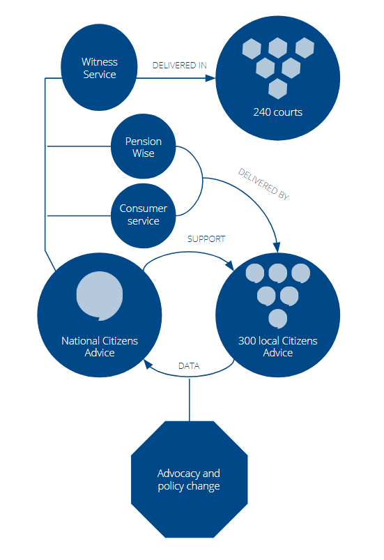

The team
The Expert Advice Team at Citizens Advice provides subject matter support and expertise to thousands of advisers across England and Wales, and helps to ensure the accuracy of our online content.

The Expert Advice team supports the local network of Citizens Advice services and our national online content team in major advice areas such as debt, benefits, housing, employment, immigration, family and consumer rights.

 The role

The Legislative Researcher/Paralegal will support the Expert Advice team’s Brexit project work by tracking legislation and documents published as part of the UK’s preparations for exiting the EU. The postholder will be responsible for identifying where changes impact our existing digital content or training, flagging these to the relevant subject matter experts and working with them to ensure changes to content or training are appropriately prioritised and accurately communicated to advisers and the public.

The Legislative Researcher/Paralegal will also support the Expert Advice team’s wider work by undertaking research for subject matter experts in our areas of advice - these include welfare benefits, consumer rights, employment law, housing, immigration, family and debt.

This role is based in a team of high-performing subject matter experts and qualified lawyers. The postholder must have an interest in law and experience of legal research, but a law degree is not a requirement and you don’t need to be a qualified solicitor or barrister.

This is a fixed term contract until 31 March 2020. The role is up to full-time and the salary is £26,960 (pro rata if part-time) + London weighting of £3,520 if applicable.

Role profile
Legislative Researcher/Paralegal

This is a fixed term contract until 31 March 2020. The role is up to full-time and the salary is £26,960 (pro rata if part-time) + London weighting of £3,520 if applicable.
Role profile

Band | Officer
Reporting to | Expert Advice Delivery Manager
Proficient salary | £26,960 (pro rata if part time) + London weighting £3,520 if applicable
Office locations | London, Leeds or Birmingham
Role purpose | To support the Expert Advice team’s Brexit project work and other functions.
Main responsibilities | Key elements/tasks |  | % of time
1. Support team’s Brexit project work | Provide reliable and efficient support to the delivery of legal legal advice on Brexit, including tracking legislation and government documents relating to the UK’s exit from the EU.  Research other information sources to understand the wider context and impact of the government decisions.  Research and understand the impact of legislative changes to our advice content and learning materials.  Appropriately prioritise and deliver content and learning updates.  Maintain a central resource containing details of new legislation that can be used by the Brexit project team. |  | 45%
2. Support team with legal research | Research new and emerging legislation, case law and other legal changes that impact our core advice areas.  Work with subject matter experts to understand the impact of these changes on our advice content and training.  Appropriately prioritise and deliver content and training updates. |  | 30%
3. Contribute to team’s priority projects | Support the team to deliver its priority projects, which include transforming and developing how we support advisers and addressing the knowledge gaps we have within the team. These projects are delivered in agile. |  | 15%
4. Other | Support the Delivery Manager to ensure the team runs effectively. This could include helping to design team meeting agendas and facilitating these meetings.  Undertake such other duties and tasks as may be reasonably required within the scope of the role. |  | 10%

Person specification
Essential criteria

- Strong understanding and interest in the law and legal research. You don’t need to be a qualified solicitor or barrister, but do need experience of legal research in an academic or practical setting

- Understanding of parliamentary and legislative process

- Ability to interpret different subject matter areas

- Ability to deliver research projects to deadlines by being proactive and solutions focused to ensure we meet project deadlines and objectives

- Excellent written and oral communication skills which enable you to engage with a wide range of people in a positive and collaborative way and in which equality and diversity is appropriately integrated

- Good ability to organise, plan and prioritise own workload to meet deadlines

Desirable criteria

- Keen interest in the advice sector

-----------------------------------------------------------------------------------------

Requirements for role (candidates will confirm at application stage and at interview)

- Ability to contribute to an inventive, responsible and generous organisation and team culture
- Understanding of, and commitment to, the aims and principles of the Citizens Advice service
- Willingness to travel within the UK
- A track record of commitment to equality and the positive value of diversity and a good, up to date understanding of equality and diversity and its application to the work of the business unit
- Awareness that Citizens Advice service users are at the heart of everything we do
- Ability to contribute to a culture of continuous learning and knowledge sharing

Applying for this role
Please complete the application form demonstrating how you meet the 6 essential criteria listed in the person specification. Please explain how you meet the person specification by outlining any relevant experience or examples in no more than 300 words per criteria.
Interviews will take place in London. Reasonable travel expenses will be reimbursed.
If you have any questions about this role please contact the recruiting manager, Katie King, on katie.king@citizensadvice.org.uk.

Terms and conditions
1. PROFICIENT SALARY: As advertised
Appointment may be at an initial salary level (90 or 95% of the proficient salary) or at the proficient salary, depending upon skills and abilities as assessed during the recruitment process.
If you are a designated essential car user, you will receive an Essential Car User Allowance payment in addition to your salary.
2. ANNUAL/TOTAL LEAVE
Annual leave is 26 days pro rata per annum from 1 January to 31 December, plus 4 fixed days (normally over Christmas and New Year). Additionally, there is Long Service Leave of 1-5 days after 3-7 years service.
3. PENSION SCHEME
Citizens Advice provides a Group Stakeholder scheme. Further details of this scheme will be provided to the successful applicant at offer and contract stage.
4. LEARNING AND DEVELOPMENT
Citizens Advice has a co-ordinated staff training and development strategy. This will mean that training for your current job, and future career developments relevant to Citizens Advice, will be provided and you will be encouraged to take an active role.
5. INTEREST FREE LOANS
Interest-free loans are available to purchase season tickets for travel, and for career development purposes. If you are a designated essential car user, interest-free car loans are also available.
6. SALARY SACRIFICE SCHEMES
Citizens Advice offers salary sacrifice pension and operates a Cycle to Work scheme which provide a tax-efficient method for employees to contribute to their personal pension or purchase a bicycle for commuting to work.
7. DISCLOSURE AND BARRING SERVICE CHECKS (DBS)
Some Citizens Advice positions may require the successful candidate to undergo a DBS check.
8. EQUALITY AND DIVERSITY
Citizens Advice recognises the positive value of diversity, promotes equality and challenges unfair discrimination. We recognise people with different backgrounds, skills, attitudes and experiences bring fresh ideas and perceptions, and we wish to encourage and harness these differences to make our services more relevant and approachable. Citizens Advice will not discriminate or tolerate discriminatory behaviour on the grounds of race, colour, sex, transgender, disability, nationality, national or ethnic origin, religion or belief, marital/partnership or family status, sexual orientation, age, social class, educational background, employment status, working pattern, trade union membership or any other irrelevant factor in any aspect of employment.
Our values include a commitment to equality and fairness, and to valuing each other. All our employees are expected to have read and understood our Equality and Diversity Policy and to ensure they behave in accordance with its principles. Breaches of the policy may lead to disciplinary action.
9. DIGNITY AT WORK
Citizens Advice is committed to providing a culture in which all staff value each other and are able to work together to their full potential in an inclusive environment free from harassment, bullying and other unacceptable forms of behaviour. Unacceptable behaviour in the workplace will be actively dealt with, all complaints will be taken seriously, confidentiality will be respected and victimisation of those that raise complaints will not be tolerated.
Our values include commitments to work together and value each other - all our employees are expected to have read and understood our Dignity at Work Policy and to ensure they behave in accordance with its principles. All staff are responsible for helping to create and maintain a positive and inclusive working environment free from bullying and harassment. All managers have a particular responsibility for ensuring a supportive and inclusive working environment in which dignity at work is actively promoted.
10. PROBATIONARY POLICY
New appointments are subject to a six months probationary period. Performance is reviewed after three months and again after six months. At the end of the probationary period the outcome of the assessment may be confirmation of post; notice of dismissal; or at Citizens Advice’s discretion, an extension of the probationary period by a further three months.
11. POLITICAL IMPARTIALITY
An important part of the principle of impartiality is that Citizens Advice staff are seen to be upholding the principle of party political impartiality. To avoid possible misunderstanding or possible conflicts of interest, guidelines have been established on staff taking part in party political activities. If you currently hold, or are intending to stand for local or national party political office, we will expect you to tell us about this if shortlisted for interview.
13. LOCATION
As advertised
14. EMPLOYMENT STATUS
As advertised
15. FLEXIBILITY
Our roles are open to discussion about flexible working, which may include arrangements such as part-time working, formalised flexitime, fixed (non-standard) working hours, working from home and job-sharing.
16. HOURS OF WORK
Normal full time working hours are 9am - 5.15pm, Monday to Friday, although these hours may vary from week to week to meet the needs of the job. Staff may be able to agree a different working pattern with their manager.
Citizens Advice is an operating name of The National Association of the Citizens Advice Bureaux.

 What we give our staff
We value the people who work here - and we show that in what we offer. As well as things like annual leave and our workplace pension, working at Citizens Advice means getting access to many benefits.

- A commitment to your development. We have a coordinated staff training and development strategy. This means that training will be provided both for your current job and for your development.
- Employee assistance programme. Everyone working at Citizens Advice has immediate access to professional and completely confidential counselling and legal advisory services.
- Interest free loans. We offer loans for travel season tickets, and for career development purposes. We offer interest free car loans if you’re a designated car user.
- Support when things in your life change. We’ll be there for you with options for flexible working, career breaks, and support for parents and carers.
- Great everyday deals. Working at Citizens Advice gives you access to a number of deals and discounts via our Your rewards discount scheme.
You can find out more about what we offer our employees on our website.

 | Equality and diversity at Citizens Advice
Citizens Advice is fully committed to stand up and speak up for those who face inequality and disadvantage. We want this to be reflected in the diversity of the people who work for us.
To help us achieve this, we aim to make our recruitment process as fair as it can be. We also offer support to disabled candidates to make sure no one loses out on a role because of their condition.
- We judge the application, not the person. The select panel won’t see your personal details. This makes sure each person’s response is judged on its merits and not on their background.
- We offer a guaranteed interview scheme. If you have a disability and your application meets the minimum criteria for the post, we’ll interview you for it. Find out more here.
- We’re a Disability Confident employer. We’re committed to changing attitudes towards disability, and making sure disabled people have the chance to fulfil their aspirations. You can find out more on our website.
- We’re part of the Equality and Diversity Forum. This means we’re committed to progress on age, disability, gender, race, religion and belief, sexual orientation and broader equality and human rights issues. Find out more here.

Our commitment to equality runs through everything we do - read our Stand up for Equality Strategy to find out more.

