Job Title | Autism and Self-Advocacy Lead | 
Role Purpose | This new role will focus on improving MacIntyre's support for Autistic people and improving public perception of MacIntyre as an expert organisation in the field of Autism. The person will also work with people with learning disabilities and Autistic people that MacIntyre supports to assist them with self-advocating about their needs, thoughts and feelings about their care and issues relating to their experience as neurodivergent people in a wider context.

Key Roles
The exact roles and ways of achieving these will be agreed with the successful candidate based on their individual gifts, skills and passions. This list should therefore be seen as a guide for recruitment and interview. This job description will be reviewed regularly with the involvement of the successful candidate. The successful candidate will also need to be flexible and willing to contribute to wider projects, meetings and areas of work over time to meet the changing needs of the organisation.

- Role model – Demonstrate being an effective self-advocate and consistently advocate for everyone to have a voice and be listened to. Demonstrate living the MacIntyre DNA (see image below) and following the MacIntyre Staff Code of Conduct.
- Develop the self-advocacy abilities of others - Meet and communicate with people in whatever way best suits each person to assist them with self-advocating, connecting and learning more about their autism or learning disability so they can flourish. To include a virtual Autism network and support for face to face networks where people wish to form these. Where requested, support people at the start of their journeys with MacIntyre to self-advocate for the right support for a life that makes sense to them.
- Keep learning - Network with external autistic experts, attend mandatory and autism specific training and keep up with research, best practice and legal requirements including the Autism Act.
- Steer MacIntyre’s autism strategy – With support as agreed, Chair MacIntyre’s autism steering group and consult with / report to autistic people involved with MacIntyre, colleagues, Directors and Trustees and together set the direction for Autism best practice across MacIntyre.
- Staff training – With other autistic people, create and update training and other resources to challenge thinking, raise standards of support and meet best practice and regulatory guidance. Deliver autism training and support other autistic people to deliver training.
- Coach others as an expert with lived experience - Visit locations where MacIntyre offers support or education to observe, listen and speak with people and staff to identify ways to improve.
- Improve MacIntyre’s reputation in relation to Autism and self-advocacy – Contribute to the development and delivery of an autism focused communication plan including growing a social media presence, giving talks, developing communication materials and participating in conferences and communities of support.
- Work with others – Participate in team meetings, meetings with other colleagues and other opportunities to collaborate beyond your work plan. This includes working collaboratively with colleagues to better meet individual needs as well as contributing to the objectives of the wider best practice team and wider MacIntyre.

Skills, Qualifications, Experience | MacIntyre’s DNA
- No specific qualifications are needed for this role  - We are looking for someone who is autistic and has knowledge and understanding of autism  - Experience of self-advocacy is essential for this role  - Ability to be able to publically speak for training or conferences is essential  - Experience of working in either education, health care or social care would be desirable but not essential  - Previous experience of working with autistic people and/or people with learning difficulties is desirable but not essential  - Good computer skills and administrative skills is essential; Microsoft Office skills (Word, Excel, PowerPoint, Publisher), Teams/Zoom  - The ability to plan and keep track of own work and projects is essential. Some support will be available with this  - Ability to travel between sites either via own car or public transport is essential  - Please discuss any specific support or reasonable adjustments you may need during interview | 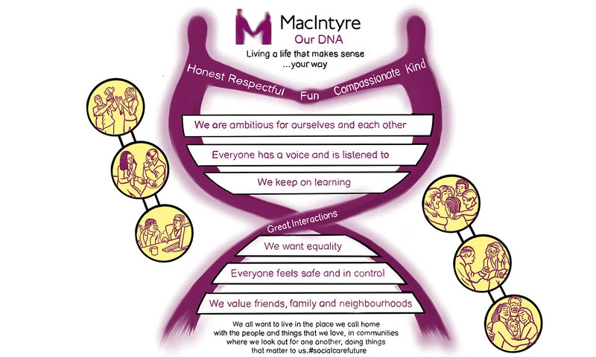
Opportunities and Potential Next Career Moves | Our Vision and Purpose
Opportunities  - Learn from your colleagues in the Best Practice team and develop a range of knowledge and skills  - Attend a range of training both internally and externally that could further own personal development including the potential to be supported to undertake a qualification related to autism  - Connect with others and have opportunities to share views and network internally and externally  Potential Next Career Moves  There are a variety of roles within the best practice team and across the organisation of varying levels, which may be of interest to you in growing and developing your career. For example, working within education or residential care or specialist teams such as the learning and development team or health team could be a possibility in the future. | Our Vision  For all people with a learning disability to live a life that makes sense to them.  Our Purpose  People who draw on MacIntyre’s support have gloriously ordinary lives, living the life they choose, using their gifts, skills and passions to contribute and connect to people in their local neighbourhood. MacIntyre invests in and helps shape neighbourhoods to be inclusive and welcoming spaces.

